

Practices for Secure Software Report

Table of Contents
Document Revision History 3
Client 3
Instructions 3
Developer 4
1. Algorithm Cipher 4
2. Certificate Generation 4
3. Deploy Cipher 4
4. Secure Communications 4
5. Secondary Testing 4
6. Functional Testing 4
7. Summary 4
8. Industry Standard Best Practices 4

Document Revision History

Version | Date | Author | Comments
1.0 | April 15, 2026 | Steven Tepsic
1.1 | April 17, 2026 | Steven Tepsic | Revisited parts 1-5 and completed form

Client



Instructions

Submit this completed practices for secure software report. Replace the bracketed text with the relevant information. You must document your process for writing secure communications and refactoring code that complies with software security testing protocols.

- Respond to the steps outlined below and include your findings.
- Respond using your own words. You may also choose to include images or supporting materials. If you include them, make certain to insert them in all the relevant locations in the document.
- Refer to the Project Two Guidelines and Rubric for more detailed instructions about each section of the template.

Developer
Steven Tepsic

Algorithm Cipher

For this instance, I would recommend the SHA-256 variant. SHA-256 is a member of the SHA-2 family, standardized by NIST in 2002. After collision attacks were demonstrated against MD5 and SHA-0 in 2004, and theoretical attacks were extended to SHA-1, NIST opened a competition to develop a next-generation standard, ultimately resulting in SHA-3 (Dumitra, 2015). SHA-256 remains unbroken and continues to be recommended alongside SHA-3. Both are also listed by Oracle’s list of cipher algorithms (Oracle, 2017).

SHA-256 produces a fixed 256-bit digest using the Merkle-Damgård construction, processing input in 512-bit blocks over 64 rounds of computation (Dumitra, 2015). SHA-256 is a hash function, not a cipher, so it operates without symmetric or asymmetric keys. Rather than encrypting data, it produces a unique fingerprint of the input, which makes it computationally infeasible to reverse the hash or find two different inputs that produce the same output (Dumitra, 2015).

Cryptographic hash functions have evolved significantly over time. From basic written encryption, to computational encryption, and then encryption designed to defeat quantum computers. Early algorithms like MD4 and MD5 were eventually broken, leading to the SHA family developed by NIST. SHA-256 represents the current practical standard, with SHA-3 (Keccak) existing as a complementary alternative using a fundamentally different sponge construction rather than Merkle-Damgård (Dumitra, 2015).

Certificate Generation

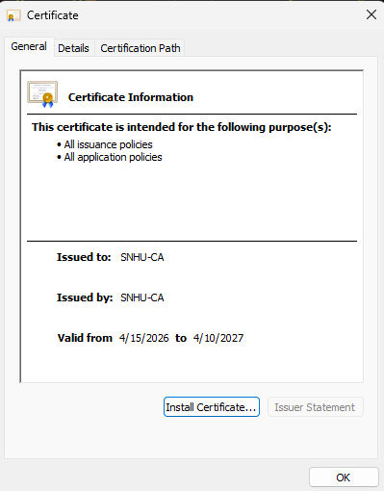

Deploy Cipher

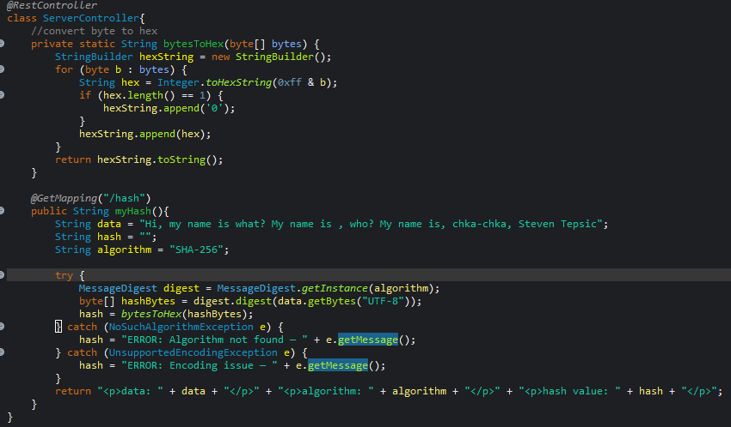

Secure Communications

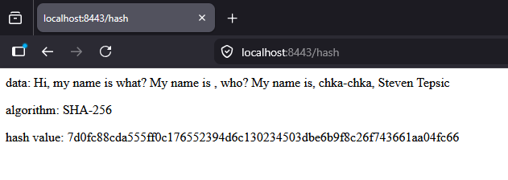

Secondary Testing
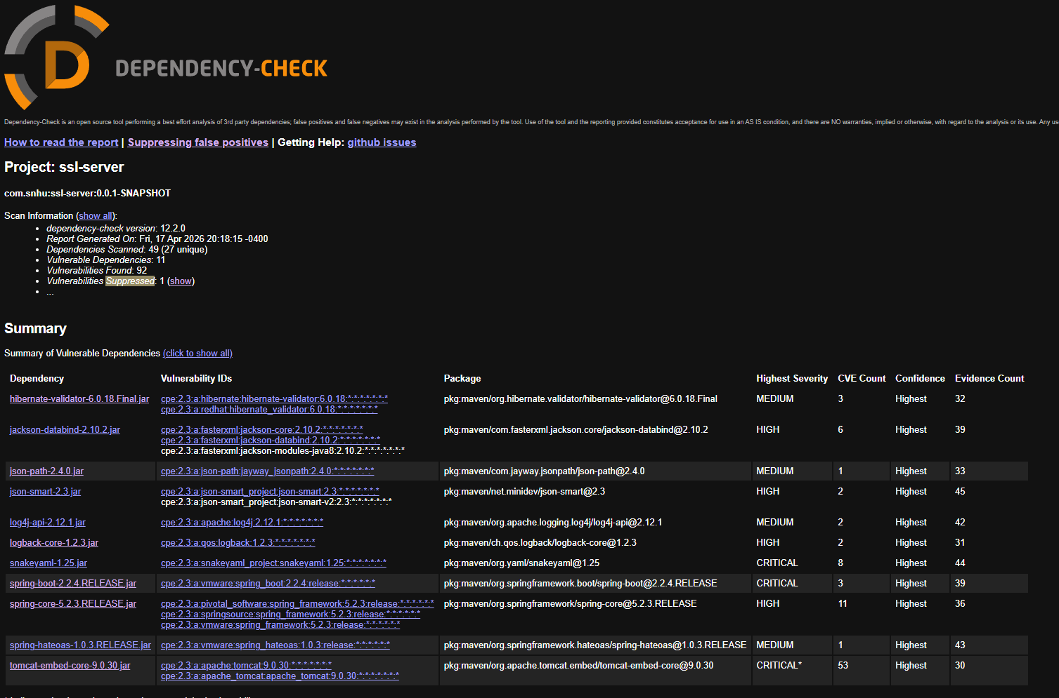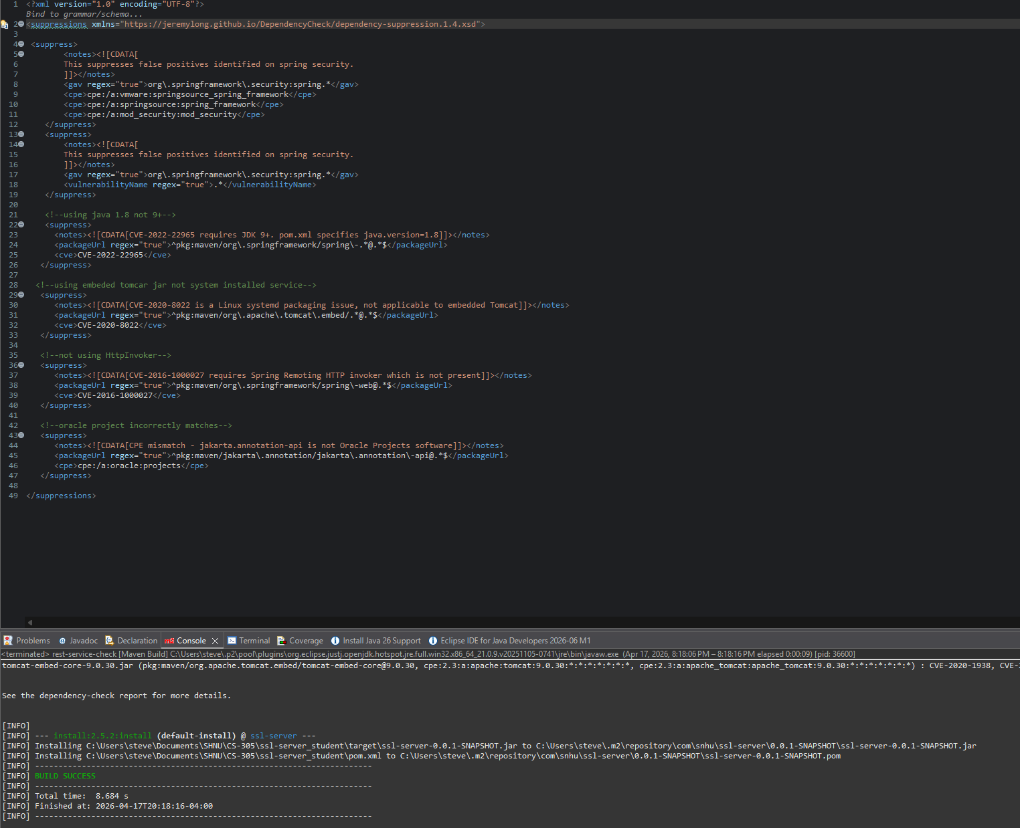

Functional Testing
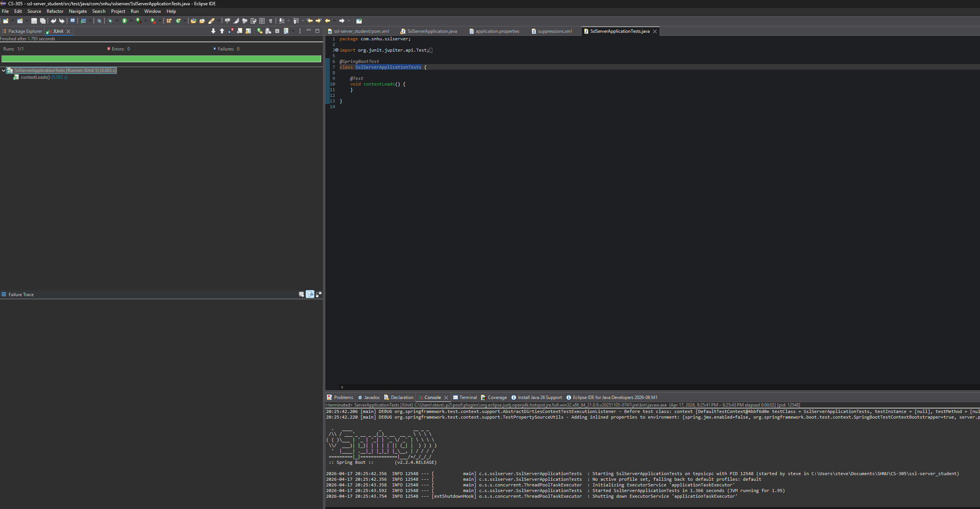
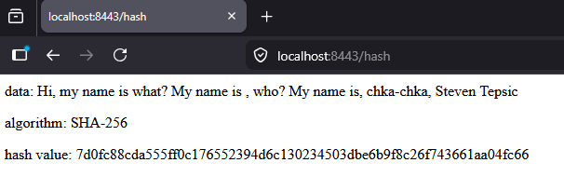

Summary

The first part of the vulnerability assessment process flow is the architecture review. The program is a web application that did not include any data encryption, no SSL certificate, and an outdated OWASP Dependency-Check plugin (version 5.3.0). After updating the plugin to version 12.2.0, running the dependency check, and suppressing confirmed false positives, the architecture review determined the scope of the manual code review needed.

Starting with input validation, this is not a concern for this application because all data is hardcoded, no user input is accepted. Next, the API was reviewed and found to have no external user interactions, making it secure in its current form. Cryptography was the primary area of focus, where SHA-256 was implemented using Java's MessageDigest class to produce a checksum of the application data. Following that, client-server security was addressed by configuring TLS through Java's keytool utility, which generates a key pair and self-signed certificate stored in a keystore file, enabling HTTPS on port 8443. Code errors are handled with try-catch blocks in the hashing function, catching both NoSuchAlgorithmException and UnsupportedEncodingException and returning controlled error messages rather than exposing stack traces. Finally, code quality and encapsulation were verified — the simplicity of the program, with a single controller class and one endpoint, makes both straightforward to confirm. The last step was verifying that the refactored code runs without errors and returns the expected hash output.

Industry Standard Best Practices

Industry standard best practices were implemented throughout the project using standard Java security tools, including the keytool utility and the MessageDigest class. Best practices were also maintained through the use of SHA-256, a NIST-approved hashing algorithm, and OWASP Dependency-Check for third-party library vulnerability scanning. Both NIST and OWASP are highly respected authorities in the cybersecurity space, making their standards a reliable foundation for secure development decisions. Another application of industry best practices was the implementation of HTTPS with Transport Layer Security, ensuring all communication between the client and server is encrypted in transit. One known drawback is the hardcoding of the keystore password in application.properties, which in a real-world environment would be pulled from an external secrets manager or environment variable rather than stored in plaintext.

One of the main values of applying these practices for Artemis Financial is risk reduction. TLS encryption ensures that even if an attacker intercepts transmitted data, they are unable to read it. The SHA-256 checksum provides a separate layer of data integrity verification, allowing the recipient to confirm that the data has not been altered in transit. Together these two mechanisms address both confidentiality and integrity, two of the core pillars of information security. The other benefit to Artemis is a strong reputation around security and confidentiality. Companies that do not deploy secure coding practices frequently become victims of attacks and lose consumer confidence as a result. For a financial consulting firm handling clients' savings, retirement, and investment data, that confidence is a direct business asset.

References

Dumitra, S. (2015). Sha Family Functions. Journal of Applied Quantitative Methods, 10(3), 47–58.

Oracle. (2017). Java security standard algorithm names: Cipher algorithm names. Java Platform,
Standard Edition 9. https://docs.oracle.com/javase/9/docs/specs/security/standard-
names.html#cipher-algorithm-names

